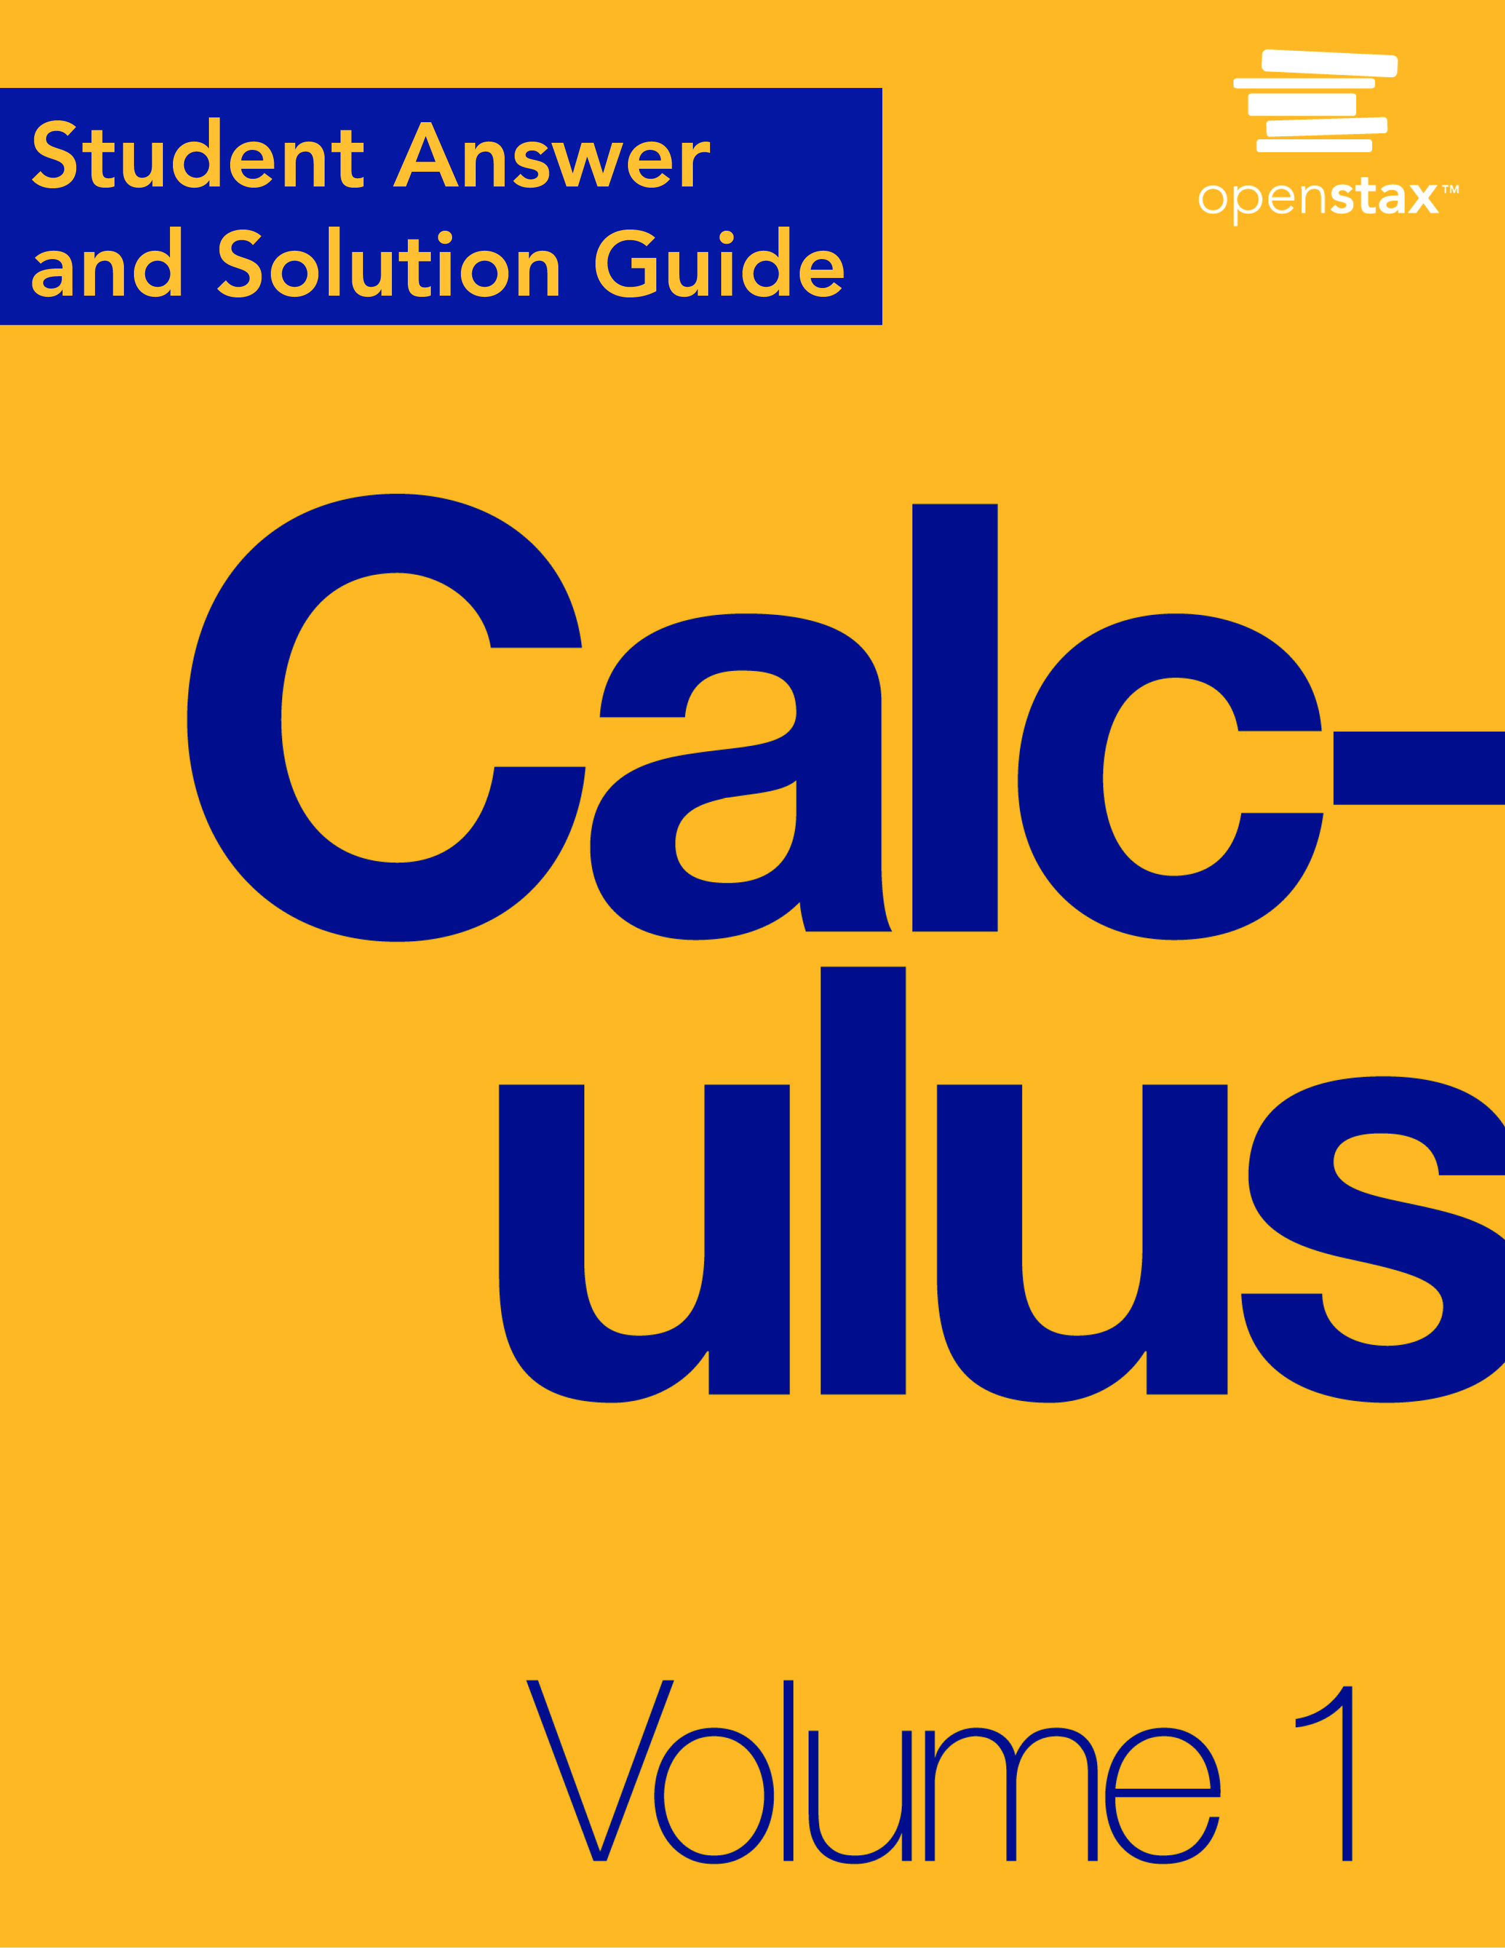

**Chapter 1**

**Functions and Graphs**

**1.1 Review of Functions**

**Section Exercises**

**For the following exercises, (a) determine the domain and the range of each relation, and (b) state whether the relation is a function.**

1.

|  |  |  |  |
| --- | --- | --- | --- |
|  |  |  |  |
| –3 | 9 | 1 | 1 |
| –2 | 4 | 2 | 4 |
| –1 | 1 | 3 | 9 |
| 0 | 0 |  |  |

Answer: a. Domain =  range =  b. Yes, a function

3.

|  |  |  |  |
| --- | --- | --- | --- |
|  |  |  |  |
| 1 | –3 | 1 | 1 |
| 2 | –2 | 2 | 2 |
| 3 | –1 | 3 | 3 |
| 0 | 0 |  |  |

Answer: a. Domain =  range =  b. No, not a function

5.

|  |  |  |  |
| --- | --- | --- | --- |
|  |  |  |  |
| 3 | 3 | 15 | 1 |
| 5 | 2 | 21 | 2 |
| 8 | 1 | 33 | 3 |
| 10 | 0 |  |  |

Answer: a. Domain =  range =  b. Yes, a function

**For the following exercises, find the values for each function, if they exist, then simplify.**

**a.  b.  c.  d.  e.  f. **

7. 

Answer: a.  b. 3 c. 13 d.  e.  f. 

9. 

Answer: a. Undefined b. 2 c  d.  e  f. 

11. 

Answer: a.  b.  c.  d.  e.  f. 

13. 

Answer: a. 9 b. 9 c. 9 d. 9 e. 9 f. 9

**For the following exercises, find the domain, range, and all zeros/intercepts, if any, of the functions.**

15. 

Answer:  no *y*-intercept

17. 

Answer: 

19. 

Answer: ; no *x*-intercept; 

21. 

Answer:  no intercepts

**For the following exercises, set up a table to sketch the graph of each function using the following values: **

23. 

|  |  |  |  |
| --- | --- | --- | --- |
|  |  |  |  |
| –3 | –15 | 1 | –3 |
| –2 | –12 | 2 | 0 |
| –1 | –9 | 3 | 3 |
| 0 | –6 |  |  |

Answer:

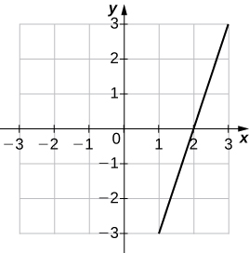

25. 

|  |  |  |  |
| --- | --- | --- | --- |
|  |  |  |  |
| –3 | 6 | 1 | 2 |
| –2 | 4 | 2 | 4 |
| –1 | 2 | 3 | 6 |
| 0 | 0 |  |  |

Answer:

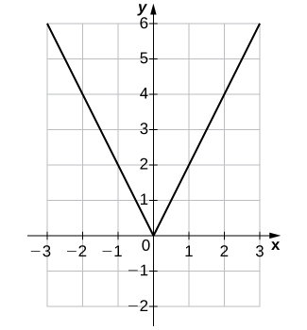

27. 

|  |  |  |  |
| --- | --- | --- | --- |
|  |  |  |  |
| –3 | –27 | 1 | 1 |
| –2 | –8 | 2 | 8 |
| –1 | –1 | 3 | 27 |
| 0 | 0 |  |  |

Answer:

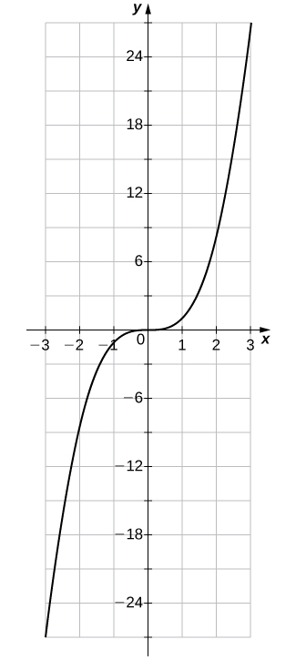

**For the following exercises, use the vertical line test to determine whether each of the given graphs represents a function. Assume that a graph continues at both ends if it extends beyond the given grid. If the graph represents a function, then determine the following for each graph:**

1. **Domain and range**
2. **-intercept, if any (estimate where necessary)**
3. **-Intercept, if any (estimate where necessary)**
4. **The intervals for which the function is increasing**
5. **The intervals for which the function is decreasing**
6. **The intervals for which the function is constant**
7. **Symmetry about any axis and/or the origin**
8. **Whether the function is even, odd, or neither**

29.

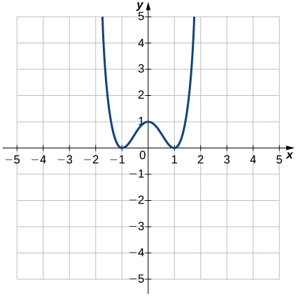

Answer: Function; a. Domain: all real numbers, range:  b.  c.  d.  and  e.  and  f. Not constant g. *y*-axis h. Even

31.

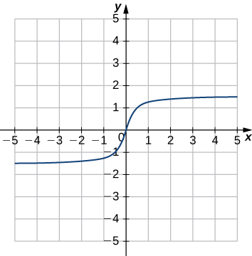

Answer: Function; a. Domain: all real numbers, range:  b.  c.  d.  e. None f. Not constant g. Origin h. Odd

33.

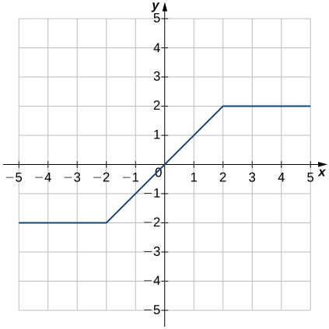

Answer: Function; a. Domain: , range:  b.  c.  d.  e. Not decreasing f.  and  g. Origin h. Odd

35.

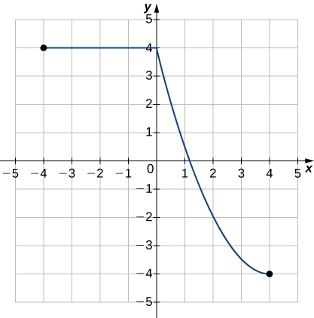

Answer: Function; a. Domain:  range:  b.  c.  d. Not increasing e.  f.  g. No Symmetry h. Neither

**For the following exercises, for each pair of functions, find a.  b.  c.  d.  Determine the domain of each of these new functions.**

37. , 

Answer: a.  all real numbers b.  all real numbers c.  all real numbers d. ; 

39. , 

Answer: a.  all real numbers b.  all real numbers c.  all real numbers d. ; 

41. , 

Answer: a.   b. 6;  c.   d.  

**For the following exercises, for each pair of functions, find a. and b.  Simplify the results. Find the domain of each of the results.**

43. , 

Answer: a.  all real numbers b.  all real numbers

45. , 

Answer: a. ; all real numbers b. ; all real numbers

47. , 

Answer: a.  b. ; 

1. The table below lists the NBA championship winners for the years 2001 to 2012.

|  |  |
| --- | --- |
| **Year** | **Winner** |
| 2001 | LA Lakers |
| 2002 | LA Lakers |
| 2003 | San Antonio Spurs |
| 2004 | Detroit Pistons |
| 2005 | San Antonio Spurs |
| 2006 | Miami Heat |
| 2007 | San Antonio Spurs |
| 2008 | Boston Celtics |
| 2009 | LA Lakers |
| 2010 | LA Lakers |
| 2011 | Dallas Mavericks |
| 2012 | Miami Heat |

1. Consider the relation in which the domain values are the years 2001 to 2012 and the range is the corresponding winner. Is this relation a function? Explain why or why not.
2. Consider the relation where the domain values are the winners and the range is the corresponding years. Is this relation a function? Explain why or why not.

Answer: a. Yes, because there is only one winner for each year. b. No, because there are three teams that won more than once during the years 2001 to 2012

51. **[T]** The volume of a cube depends on the length of the sides 

1. Write a function  for the area of a square.
2. Find and interpret 

Answer: a.  b. ; a cube of side length 11.8 each has a volume of approximately 1643 cubic units.

53. **[T]** A vehicle has a 20-gal tank and gets 15 mpg. The number of miles *N* that can be driven depends on the amount of gas *x* in the tank.

1. Write a formula that models this situation.
2. Determine the number of miles the vehicle can travel on (i) a full tank of gas and (ii) 3/4 of a tank of gas.
3. Determine the domain and range of the function.
4. Determine how many times the driver had to stop for gas if she has driven a total of 578 mi.

Answer: a. b. i.  therefore, the vehicle can travel 300 mi on a full tank of gas. Ii.  therefore, the vehicle can travel 225 mi on 3/4 of a tank of gas. c. Domain: ; range:  d. The driver had to stop at least once, given that it takes approximately 39 gal of gas to drive a total of 578 mi.

55. **[T]** A certain bacterium grows in culture in a circular region. The radius of the circle, measured in centimeters, is given by , where *t* is time measured in hours since a circle of a 1-cm radius of the bacterium was put into the culture.

1. Express the area of the bacteria as a function of time.
2. Find the exact and approximate area of the bacterial culture in 3 hours.
3. Express the circumference of the bacteria as a function of time.
4. Find the exact and approximate circumference of the bacteria in 3 hours.

Answer: a.  b. Exact: ; approximately 95 cm2 c.  d. Exact:  approximately 35 cm

57. **[T]** The manager at a skateboard shop pays his workers a monthly salary *S* of $750 plus a commission of $8.50 for each skateboard they sell.

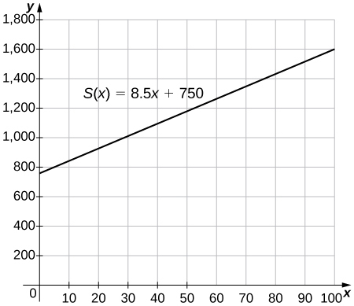

1. Write a function  that models a worker’s monthly salary based on the number of skateboards *x* he or she sells.
2. Find the approximate monthly salary when a worker sells 25, 40, or 55 skateboards.
3. Use the INTERSECT feature on a graphing calculator to determine the number of skateboards that must be sold for a worker to earn a monthly income of $1400. (Hint: Find the intersection of the function and the line .)

Answer: a. b. $962.50, $1090, $1217.50 c. 77 skateboards

This file is copyright 2016, Rice University. All Rights Reserved.